NorthStar Casino Ontario Review: The Only Toronto-Built Casino App?
Affiliate disclosure: OntarioGamers.ca earns commission when you sign up through our links — at no extra cost to you. This does not influence our editorial recommendations.

NorthStar Bets Casino Ontario
Overall rating | 8.6/10
Operator’s legal name | NorthStar Bets Casino Ontario
Parent company | NorthStar Gaming Holdings Inc.
AGCO registration | Active under license no. OPIG1226485
Launch date in Ontario | May 2022
Minimum deposit | $20
Minimum withdrawal | $20
Total games count | 2,800+
Major providers | 32+, including Konami, Hacksaw Gaming, Greentube, and Pragmatic Play
Banking methods | Visa, MasterCard, Interac, Instadebit
Withdrawal time | 3 hours - 3 days
Mobile support | Yes; browser-friendly website, iOS & Android app
Age requirement | 19+
Play Now at NorthStar Bets
19+ | Ontario Only | Play Responsibly

Overview & Legal Status
NorthStar Bets Casino Ontario has something many of its competitors can’t claim: a genuine home-field advantage. Owned and operated by Toronto-based NorthStar Gaming Holdings Inc., the brand has deep local roots and a sports content tie-in with the Toronto Star. Its “Built by Canadians for Canadians” positioning puts that connection front and centre.
But local credentials only go so far. What matters to Ontario players is how NorthStar Bets actually performs once you start playing. From the moment I landed on the site, I was met with a clean, modern interface that hosts a solid 2,800+ game lobby, AGCO protections, and clear banking processes.
But how does the overall experience hold up? This NorthStar Bets Casino review walks through the entire platform to see where it stands in the booming Ontario online casino scene.
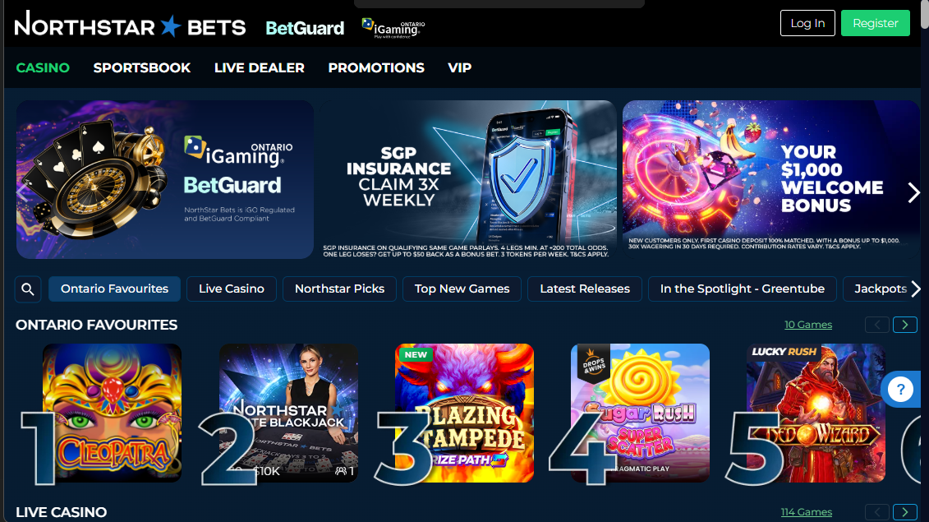

NorthStar Bets Casino ON Pros & Cons
Pros | Cons
- A genuine Canadian brand with aToronto Star sports content tie-in | - Lacks a dedicated slots tab
- AGCO-registered and BetGuard-complaint | - Higher minimum limits than most Ontario rivals
- Well-structured game lobby | - No demo mode
- Over 2,800 high-quality titles from top providers | - Limited banking options
- Localised support

Getting Started at NorthStar Bets Ontario
Registering at NorthStar Bets Casino was smooth and took under two minutes. Here’s how to sign up at NorthStar Bets:
Step 1: Tap the bright green ‘Register’ tab at the top right to reveal the sign up form.
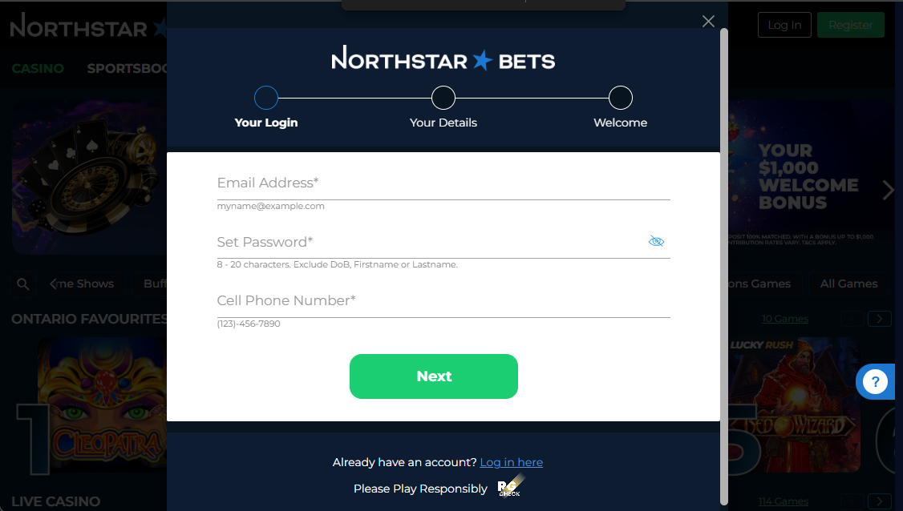
The first screen prompts you to enter your email, set a password, and add your ON-phone number. Once complete, click ‘Next.’
Step 2: Enter more personal data
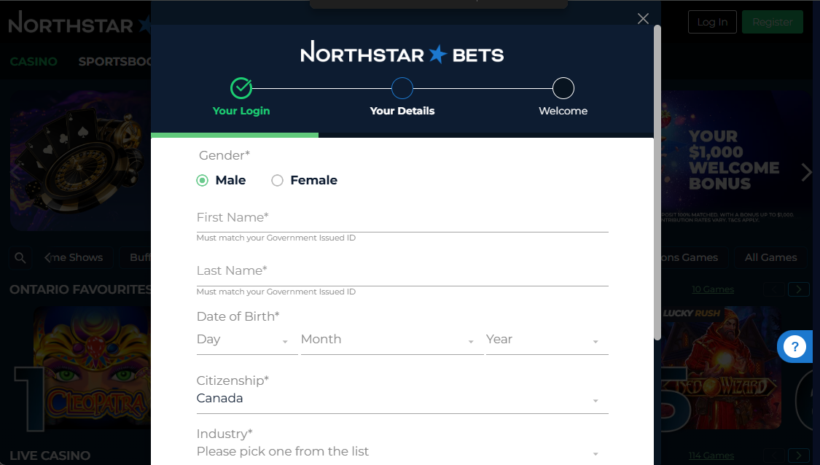
On the next screen, add your name, birthdate, gender, citizenship, and occupation before tapping ‘Next.’
Step 3: Enter your address
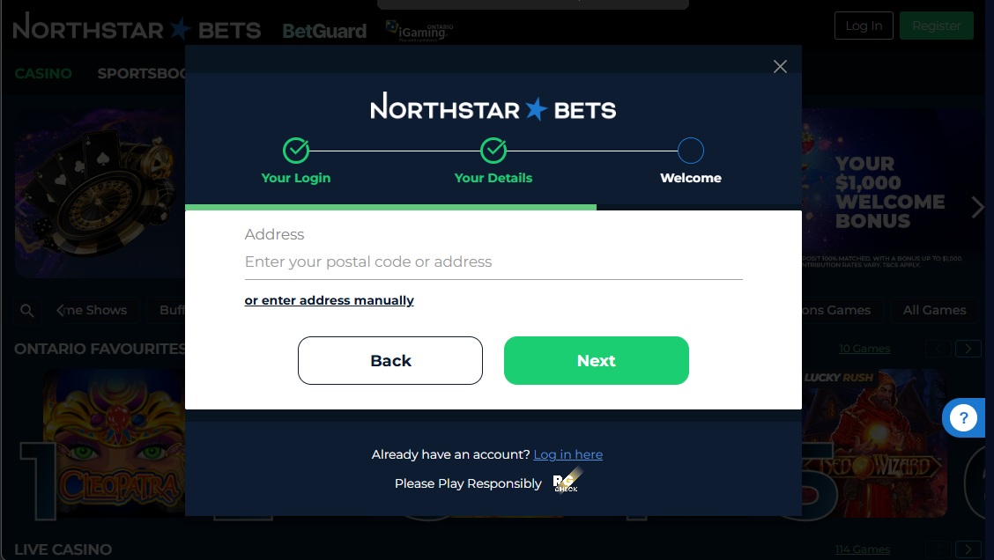
Enter your postal code then pick your address from the dropdown list. Alternatively, you can find your address manually when you add your province, city, postal code, street number, house/building number, and apt/unit number.
Step 4: Agree to the T&Cs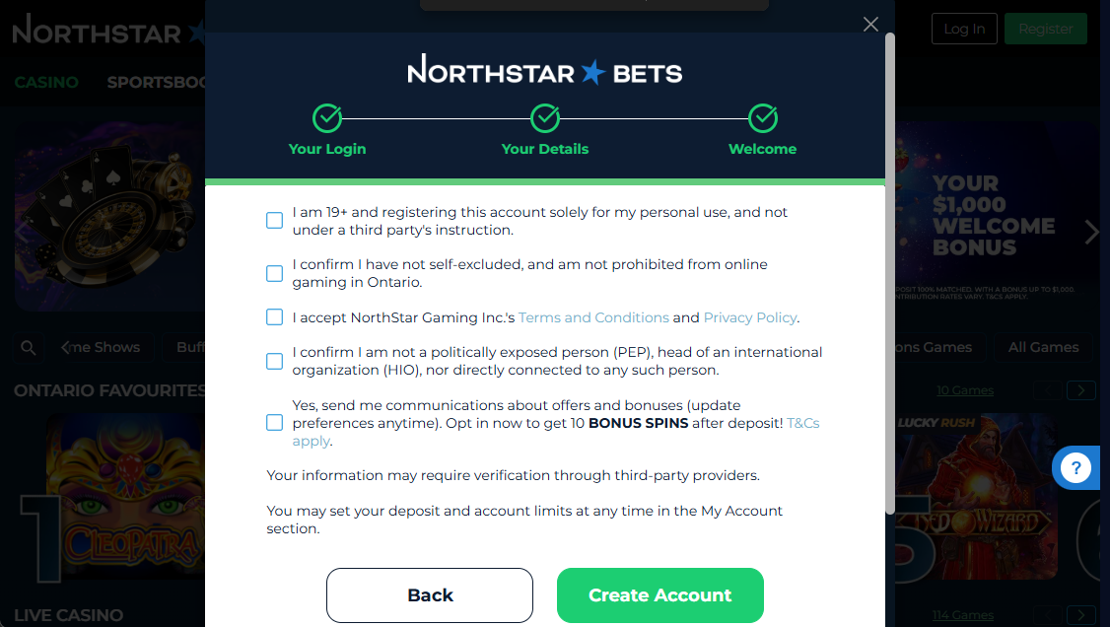
Verify you’re 19+, fit to play in Ontario, not a politically exposed person or directly connected to one, and agree to the site’s T&Cs. Click ‘Create Account’ to finish.
Once your NorthStar Bets Casino login is successful, you’ll be instantly redirected to the banking page to transfer funds and start playing.

Verifying Your NorthStar Bets Casino Account in Ontario
Unlike my experience during the Jackpot City Casino review where I had to verify my account before logging in and accessing the banking page, NorthStar Bets let me fund my account before prompting me to ‘Start verification.’ Do note, however, that I had to complete this step before I could start playing online casino games with real money.
The account verification process was one of the smoothest and quickest I’ve experienced. All I had to do was allow my device to take a photo or submit a copy of my Canadian passport, driver’s license, or national ID card for proof of identity and bank statement or utility bill as proof of address. My verification was instant, although the operator says the process can take up to 72 hours.
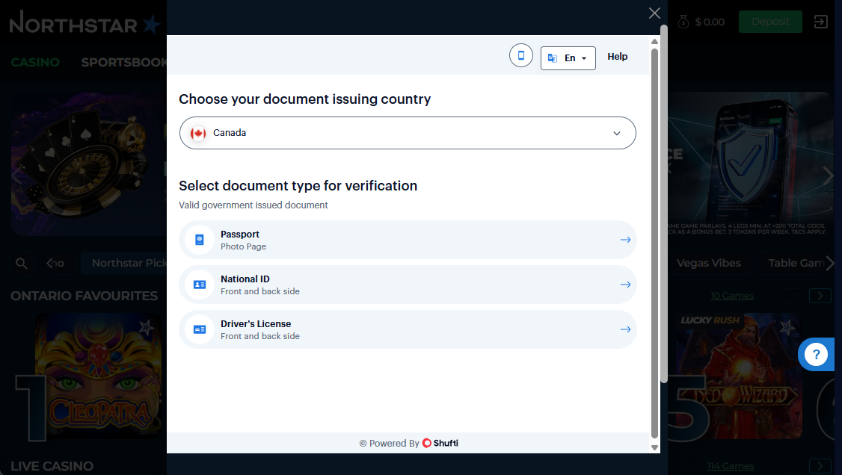

NorthStar Bet Casino ON Games
NorthStar Bet Ontario sits in the mid-tier level for catalogue quantity, with around 2,800 total games. It clearly outpaces smaller libraries like Betway Ontario’s 1,500+.
But what stands out about NorthStar Bets gaming lobby is its detailed structure. Instantly jump into Ontario favourites, live casino, NorthStar picks, top new games, latest releases, in the spotlight, jackpots, vegas vibes, and much more with a single click.
The only thing that was missing was a dedicated slots page. During testing, I found slot titles spread across themed carousels covering cascading reels, Megaways, jackpots, Drops & Wins, Egyptian games, fishing, and more.
I’d love to see one full list of slots where players can scroll through all available titles without having to switch between different categories. That said, the search bar and detailed filter tool make finding specific games much easier.

Slots
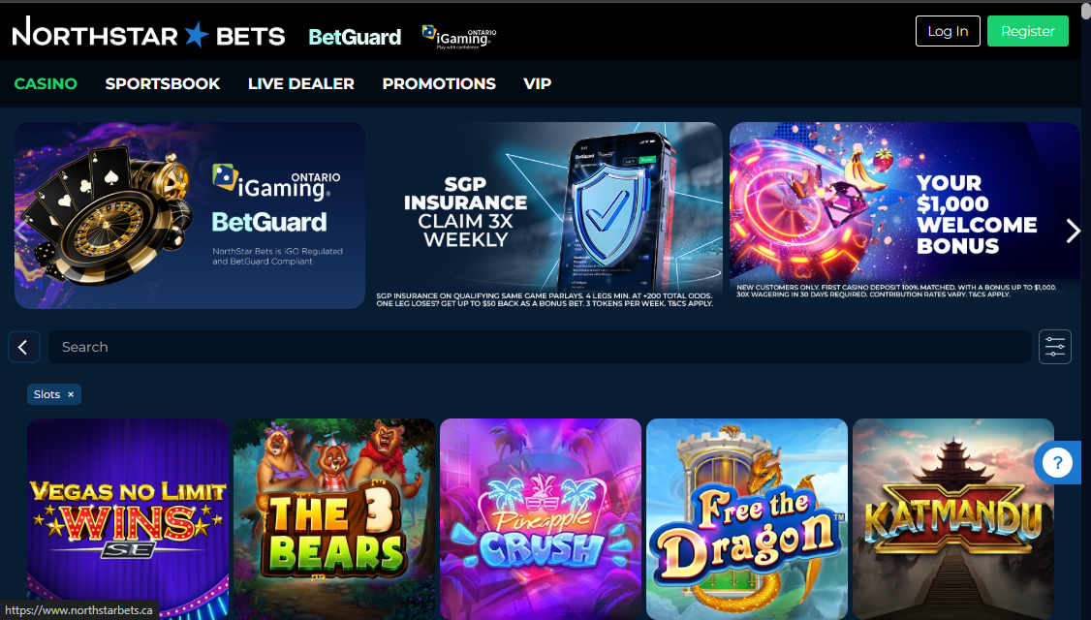
Instead of a dedicated slots lobby, NorthStar Bets’ 2,100+ online slots sit in themed shelves like Jackpots, Buffalo, Egyptian, Fishing, Sweet, Retro Reels, Lucky Rush, Cascading Reels, and more. While this works well for players who know what they like, those who prefer to scan entire selections and spot titles may find it a bit restrictive. In this case, the Type filter’s ‘Slots’ selection will be useful when exploring available slots.
The variety itself is strong, with 32+ trusted providers, including Playtech, Pragmatic Play, Greentube, and Games Global powering it. Titles such as Cleopatra, 3 Mystic Lamps, and Gates of Olympus Super Scatter loaded quickly and ran glitch-free on desktop and the NorthStar Bets app.
I particularly enjoyed diving into the Diamond Cash Mighty Buffalo jackpot slot. Despite the long odds, the herd of North American buffaloes, six jackpots, and Diamond Cash respins across the 5x4 grid and 25 paylines made every spin feel alive.

Table Games
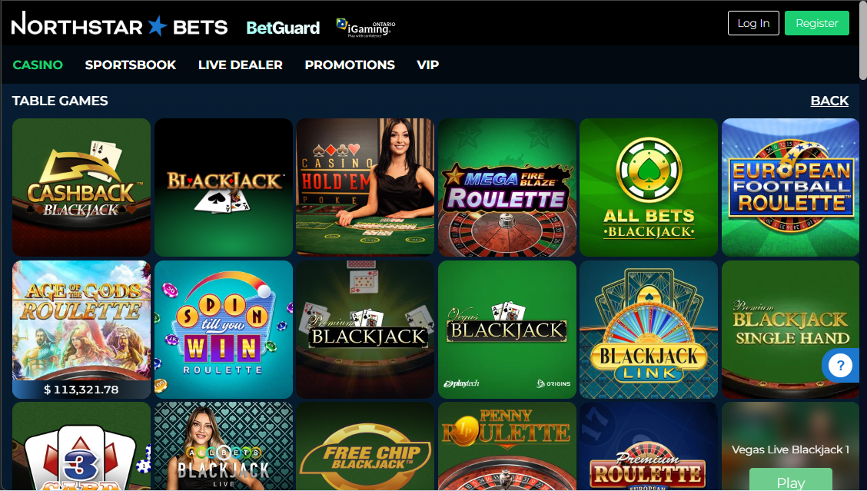
NorthStar Bets may be a slots-first casino, but its table games lineup still covers the classics. While its selection of 35+ titles sits within the standard Ontario range, you’ll find a few blackjack, roulette, video poker, and baccarat titles, mixed in with several specialty picks such as Streak of Luck: Double Dice and 3 Card Brag.
It’s not the deepest table games collection. Nonetheless, it covers the bases while still adding a splash of thrill whenever you want to step away from slots or live casino.

Live Casino
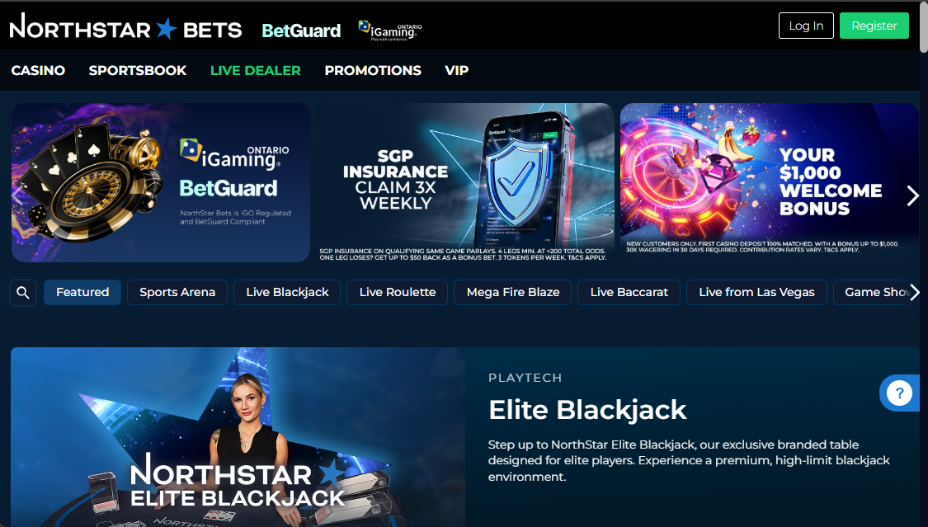
The NorthStar Bets live casino hosts 120+ titles from the likes of PlayTech, Pragmatic Play, Evolution, and NorthStar’s in-house gaming studio. I liked that each live game thumbnail displayed available bet sizes, making it easier to pick the right table. Stakes range from $0.10 to $10,000, ideal for both casual players and highrollers.
I found a few live variations of blackjack, roulette, baccarat, and game shows. But where NorthStar Bets live casino shines is its ‘Live from Vegas’ section. Playtech’s Family Feud Live from Vegas option was particularly engaging during testing for its high RTP, fast loading times, crisp stream quality, and interactive features.

NorthStar Bets Casino Ontario User Interface
NorthStar Bets Casino Ontario feels like it was built specifically for Ontario players. The platform’s dark and navy blue background feels refreshingly clean and simple. Nothing about it felt flashy or promotional even though the online casino section seems to play second fiddle to the sportsbook product.

Desktop Experience
The NorthStar Bets Ontario desktop experience felt solid and intuitive, with its themed carousels and fast category loading. Tabs like ‘Casino’, ‘Sportsbook,’ ‘Live dealer,’ ‘Promotions,’ and ‘VIP’ stay fixed at the top of the page for one-tap navigation while each carousel fits six titles per swipe for cleaner browsing.
One clear highlight was how moving through the platform felt natural. Games loaded quickly and navigation kept key sections like deposit and account settings within reach.

Mobile & App Experience
A NorthStar Bets Casino login is possible on mobile browser and via the dedicated iOS and Android apps. While writing this NorthStar Bets Casino review, iPhone users rated the app 3.6 stars from 397 NorthStar Bets Casino Ontario reviews while Android users rated it 3.8 stars with 10k+ downloads.
The mobile interface, both on browser and the apps, closely matches the desktop aesthetic. The user-friendly interface and intuitive navigation I raved about while reviewing the desktop experience comes into play on mobile too. The curated sections and advanced filter tools were especially nice as they made jumping through different sections seamless.
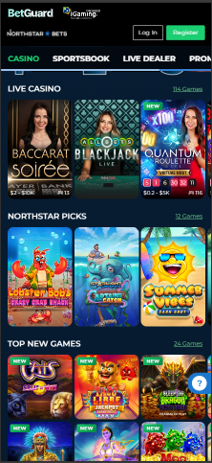

Key Reasons to Try NorthStar Bets Ontario
There’s plenty to like about NorthStar Bets Casino ON, but here are some key features I particularly enjoyed:
- A home-grown option: NorthStar Bets online casino has strong Canadian roots owing to its Toronto-based parent company. In other words, it’s among the few Ontario online casinos that’s very familiar with the culture and attitudes of Canadians.
- Curated game library: Game discovery on NorthStar Bets is one of the smoothest experiences on the platform. Themed carousels like ‘Ontario Favourites’ and ‘NorthStar Picks’ present smaller and thoughtfully selected titles, making the library easier to navigate.
- Localised customer support: NorthStar Bets casino customer support is proudly Canadian. That means players can reach support via live chat, a toll-free phone number, and email 24/7 and 365 days a year.

Banking Options at NorthStar Bets Ontario
Despite having a limited lineup of banking options, NorthStar Bets Casino ON offers a handpicked selection of popular payment methods.

Ways to Deposit Funds
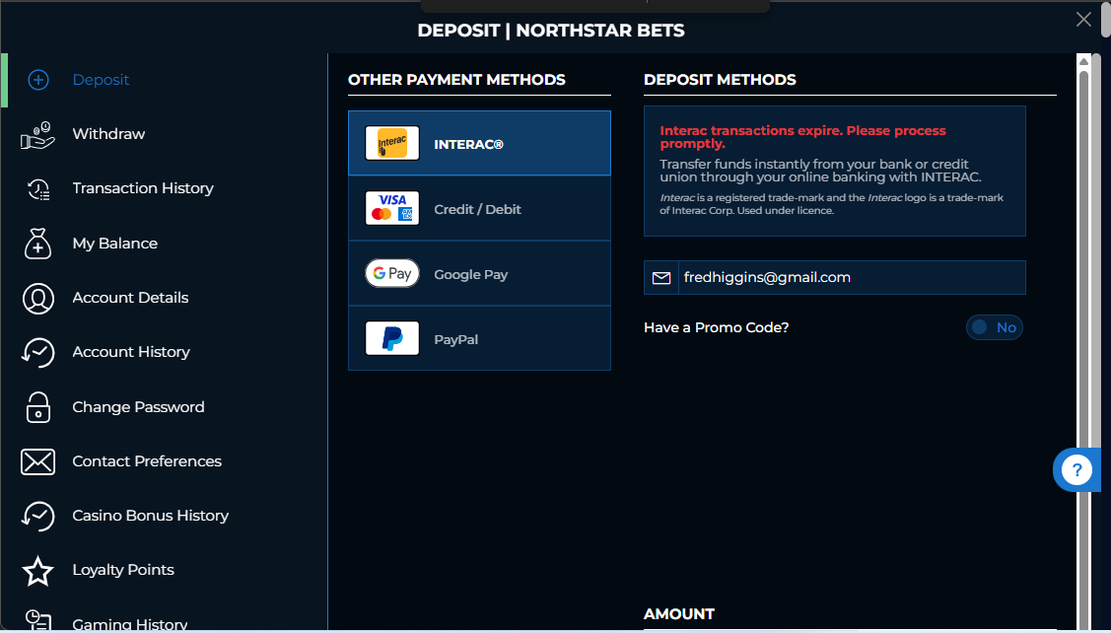
Players can fund their NorthStar Bets Ontario accounts using:
- Visa
- MasterCard
- American Express
- Interac
- PayPal
During testing, I used Interac, which has a deposit range of $20 - $9,999, the same as other deposit options available on this platform. The deposit flow was smooth after I had verified my account and funds reflected instantly in my account.

How to Withdraw Winnings
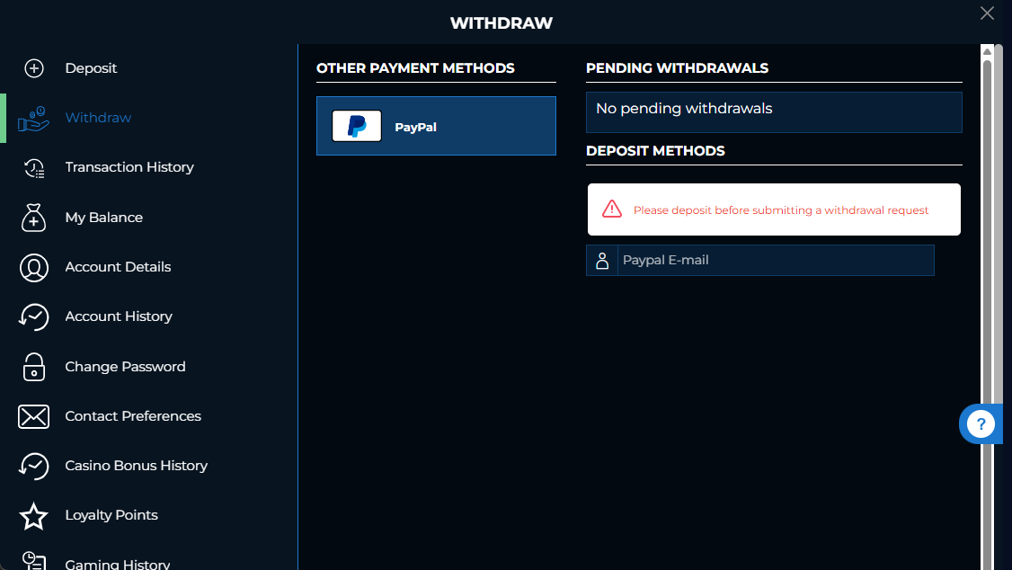
For payouts, NorthStar Bets Ontario lists Interac and PayPal as the only options, with limits starting from $20, much higher than I found during the TonyBet Ontario review. Separate help content on the platform adds Visa and Instadebit, but they were not visible in the cashier during my testing.
Also, the site doesn’t set a maximum withdrawal limit, but live chat confirmed that payouts over $10,000 may require longer processing than the promised 24 hours. The operator doesn’t charge any extra transaction costs.
Since I had already verified my account soon after account creation, my withdrawal request via Interac took about five hours. Visa cashouts, however, may take longer.

Customer Support
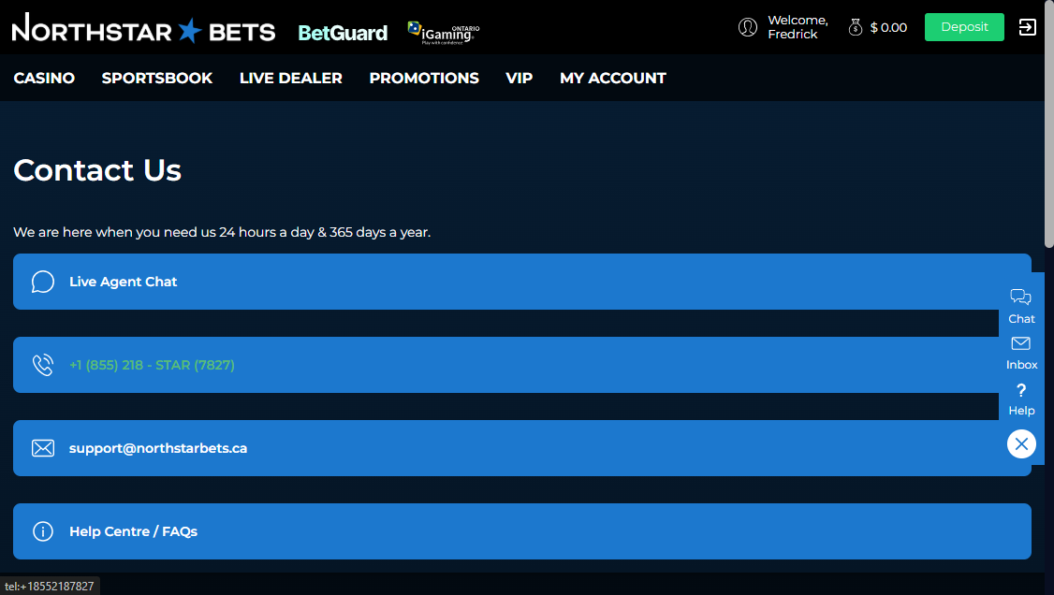
NorthStar Bets Casino Ontario offers round the clock support through live chat, email, and a toll-free phone number.
- Live chat: 24/7
- Phone: +1 (855) 218 7827
- Email: support@northstarbets.ca
- Help centre
In my direct experience with NorthStar Bets Casino Canada support, I got a real response rather quickly when I prompted live chat about a payment query. I found live chat was best for simple account fixes and fast responses, while phone support was great for immediate back and forth. Email support fits better for deeper account reviews or queries that involve a paper trail.

Responsible Gambling Tools at NorthStar Bets Ontario
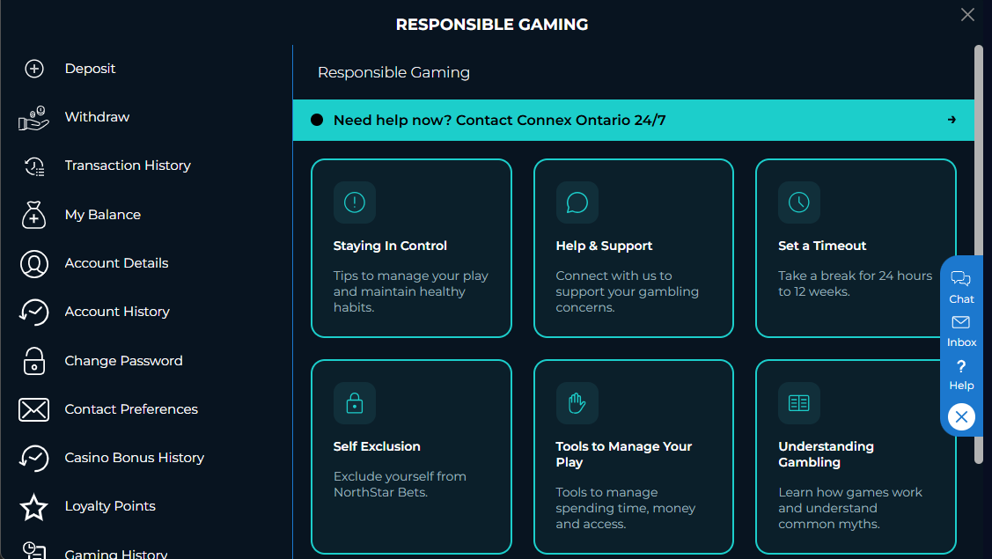
NorthStar Bets Ontario offers several responsible gambling tools on both the website and the dedicated apps. Although NorthStar Bets doesn’t prompt you to set limits immediately after the initial sign up, the tools are easy to find once you complete the NorthStar Bets casino login.
Under ‘My Account’ settings, the responsible gaming tools I found were”
- Deposit limits
- Loss limits
- Session limits
- Time out periods
- Reality checks
- Player activity statements
- Self exclusion options
During testing, my NorthStar Bets casino account would log out automatically after 20 minutes of inactivity, adding an extra layer of security. The operator has also teamed up with helpful organizations like ConnexOntario, GamblersAnonymous, and the Responsible Gambling Council to support players struggling with gambling addiction. In all, NorthStar Bets Casino Ontario appears to go well beyond the basics that provincial gambling laws require.

My Verdict on NorthStar Bets Ontario
NorthStar Bets delivers an impressive well-rounded experience tailored to Ontario players. Its navigation is among the best I’ve seen in my Ontario casino reviews, even though there are a few noteworthy omissions like the lack of a dedicated slots tab and demo options.
Overall, NorthStar Bets feels distinctively Canadian, trustworthy, and reliable with a solid mix of 2,800+ casino games and a track of smooth gameplay and intuitive navigation. If you’re looking for a trusted, polished site that balances structure and clarity, NorthStar Bets Casino Ontario is certainly worth considering.

NorthStar Bets Ontario FAQs

Is NorthStar Bets legit?
Yes. NorthStar Bets Casino is a legitimate Ontario operator with audited games, secure banking, and a long-standing Canadian presence.

Who owns NorthStar Bets?
Toronto-based NorthStar Gaming Holdings Inc. owns and operates NorthStar Bets Casino Ontario. However, the Canada-facing site is owned and operated by Conseil des Abénakis de W$ô$linak.

How fast are payouts at NorthStar Bets?
Payouts are usually processed within a few hours, but can take up to 24 hours. However, larger withdrawals over $10,000 can take longer than the maximum 72 hours.

Is there a NorthStar Bets Casino app for Android and iOS?
Yes. Ontario players can install the NorthStar Bets app for iPhone and Android from the respective app stores. Alternatively, the site also offers full mobile browser support.
